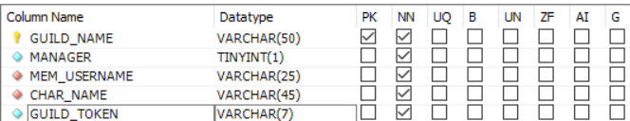

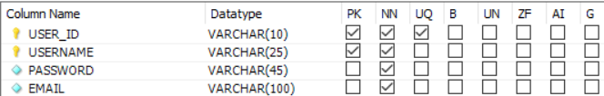

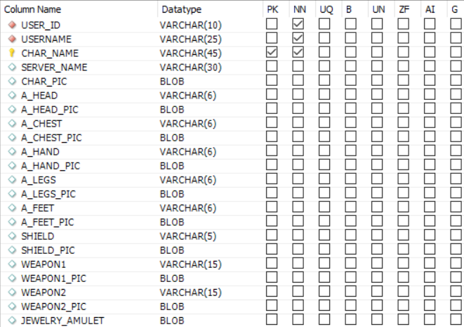



-- MySQL Workbench Forward Engineering

SET @OLD_UNIQUE_CHECKS=@@UNIQUE_CHECKS, UNIQUE_CHECKS=0;

SET @OLD_FOREIGN_KEY_CHECKS=@@FOREIGN_KEY_CHECKS, FOREIGN_KEY_CHECKS=0;

SET @OLD_SQL_MODE=@@SQL_MODE, SQL_MODE='ONLY_FULL_GROUP_BY,STRICT_TRANS_TABLES,NO_ZERO_IN_DATE,NO_ZERO_DATE,ERROR_FOR_DIVISION_BY_ZERO,NO_ENGINE_SUBSTITUTION';

-- -----------------------------------------------------

-- Schema NEW_WORLD_RPGROSTER_DB

-- -----------------------------------------------------

-- -----------------------------------------------------

-- Schema NEW_WORLD_RPGROSTER_DB

-- -----------------------------------------------------

CREATE SCHEMA IF NOT EXISTS `NEW_WORLD_RPGROSTER_DB` DEFAULT CHARACTER SET utf8 ;

USE `NEW_WORLD_RPGROSTER_DB` ;

-- -----------------------------------------------------

-- Table `NEW_WORLD_RPGROSTER_DB`.`USER`

-- -----------------------------------------------------

CREATE TABLE IF NOT EXISTS `NEW_WORLD_RPGROSTER_DB`.`USER` (

`USER_ID` VARCHAR(10) NOT NULL,

`USERNAME` VARCHAR(25) NOT NULL,

`PASSWORD` VARCHAR(45) NOT NULL,

`EMAIL` VARCHAR(100) NOT NULL,

PRIMARY KEY (`USER_ID`, `USERNAME`),

UNIQUE INDEX `USER_ID_UNIQUE` (`USER_ID` ASC) VISIBLE)

ENGINE = InnoDB;

-- -----------------------------------------------------

-- Table `NEW_WORLD_RPGROSTER_DB`.`TEMPLATE`

-- -----------------------------------------------------

CREATE TABLE IF NOT EXISTS `NEW_WORLD_RPGROSTER_DB`.`TEMPLATE` (

`USER_ID` VARCHAR(10) NOT NULL,

`USERNAME` VARCHAR(25) NOT NULL,

`CHAR_NAME` VARCHAR(45) NOT NULL,

`SERVER_NAME` VARCHAR(30) NULL,

`CHAR_PIC` BLOB NULL,

`A_HEAD` VARCHAR(6) NULL,

`A_HEAD_PIC` BLOB NULL,

`A_CHEST` VARCHAR(6) NULL,

`A_CHEST_PIC` BLOB NULL,

`A_HAND` VARCHAR(6) NULL,

`A_HAND_PIC` BLOB NULL,

`A_LEGS` VARCHAR(6) NULL,

`A_LEGS_PIC` BLOB NULL,

`A_FEET` VARCHAR(6) NULL,

`A_FEET_PIC` BLOB NULL,

`SHIELD` VARCHAR(5) NULL,

`SHIELD_PIC` BLOB NULL,

`WEAPON1` VARCHAR(15) NULL,

`WEAPON1_PIC` BLOB NULL,

`WEAPON2` VARCHAR(15) NULL,

`WEAPON2_PIC` BLOB NULL,

`JEWELRY_AMULET` BLOB NULL,

`JEWELERY_RING` BLOB NULL,

`JEWELERY_EARING` BLOB NULL,

`CHAR_DESCRIPTION` VARCHAR(250) NULL,

PRIMARY KEY (`CHAR_NAME`),

INDEX `USED_ID_idx` (`USER_ID` ASC) VISIBLE,

INDEX `USERNAME_idx` (`USERNAME` ASC) VISIBLE,

CONSTRAINT `USED_ID`

FOREIGN KEY (`USER_ID`)

REFERENCES `NEW_WORLD_RPGROSTER_DB`.`USER` (`USER_ID`)

ON DELETE NO ACTION

ON UPDATE NO ACTION,

CONSTRAINT `USERNAME`

FOREIGN KEY (`USERNAME`)

REFERENCES `NEW_WORLD_RPGROSTER_DB`.`USER` (`USERNAME`)

ON DELETE NO ACTION

ON UPDATE NO ACTION)

ENGINE = InnoDB;

-- -----------------------------------------------------

-- Table `NEW_WORLD_RPGROSTER_DB`.`GUILD`

-- -----------------------------------------------------

CREATE TABLE IF NOT EXISTS `NEW_WORLD_RPGROSTER_DB`.`GUILD` (

`GUILD_NAME` VARCHAR(50) NOT NULL,

`MANAGER` TINYINT(1) NOT NULL,

`MEM_USERNAME` VARCHAR(25) NOT NULL,

`CHAR_NAME` VARCHAR(45) NOT NULL,

`GUILD_TOKEN` VARCHAR(7) NOT NULL,

PRIMARY KEY (`GUILD_NAME`),

INDEX `MEM_USERNAME_idx` (`MEM_USERNAME` ASC) VISIBLE,

INDEX `CHAR_NAME_idx` (`CHAR_NAME` ASC) VISIBLE,

CONSTRAINT `MEM_USERNAME`

FOREIGN KEY (`MEM_USERNAME`)

REFERENCES `NEW_WORLD_RPGROSTER_DB`.`USER` (`USERNAME`)

ON DELETE NO ACTION

ON UPDATE NO ACTION,

CONSTRAINT `CHAR_NAME`

FOREIGN KEY (`CHAR_NAME`)

REFERENCES `NEW_WORLD_RPGROSTER_DB`.`TEMPLATE` (`CHAR_NAME`)

ON DELETE NO ACTION

ON UPDATE NO ACTION)

ENGINE = InnoDB;

SET SQL_MODE=@OLD_SQL_MODE;

SET FOREIGN_KEY_CHECKS=@OLD_FOREIGN_KEY_CHECKS;

SET UNIQUE_CHECKS=@OLD_UNIQUE_CHECKS;



